Question 10 – Tic-Tac-Toe Game
AIM
To write a Python program to implement the Tic-Tac-Toe game for two players, where players take alternate turns and the program determines the winner or draw.
OBJECTIVES
- To represent the Tic-Tac-Toe board using a 3 × 3 grid.
- To allow two players to make moves alternately.
- To validate the player's selected position.
- To check the board for a winning combination.
- To identify a draw when all positions are filled without a winner.
- To display the final result of the game.
ALGORITHM
- Start the program.
- Initialize a 3 × 3 Tic-Tac-Toe board with empty positions.
- Set the first player as X.
- Display the current board.
- Ask the current player to enter a valid position.
- Check whether the selected position is empty.
- If the position is occupied, ask the player to enter another position.
- Place the player's symbol (X or O) in the selected position.
- Check all rows, columns, and diagonals for three identical symbols.
- If a winning combination is found, display the winner and stop.
- If the board is full and there is no winner, display Draw and stop.
- Otherwise, switch the player from X to O or O to X.
- Repeat the process from Step 4.
- Stop the program.

FLOW CHART:
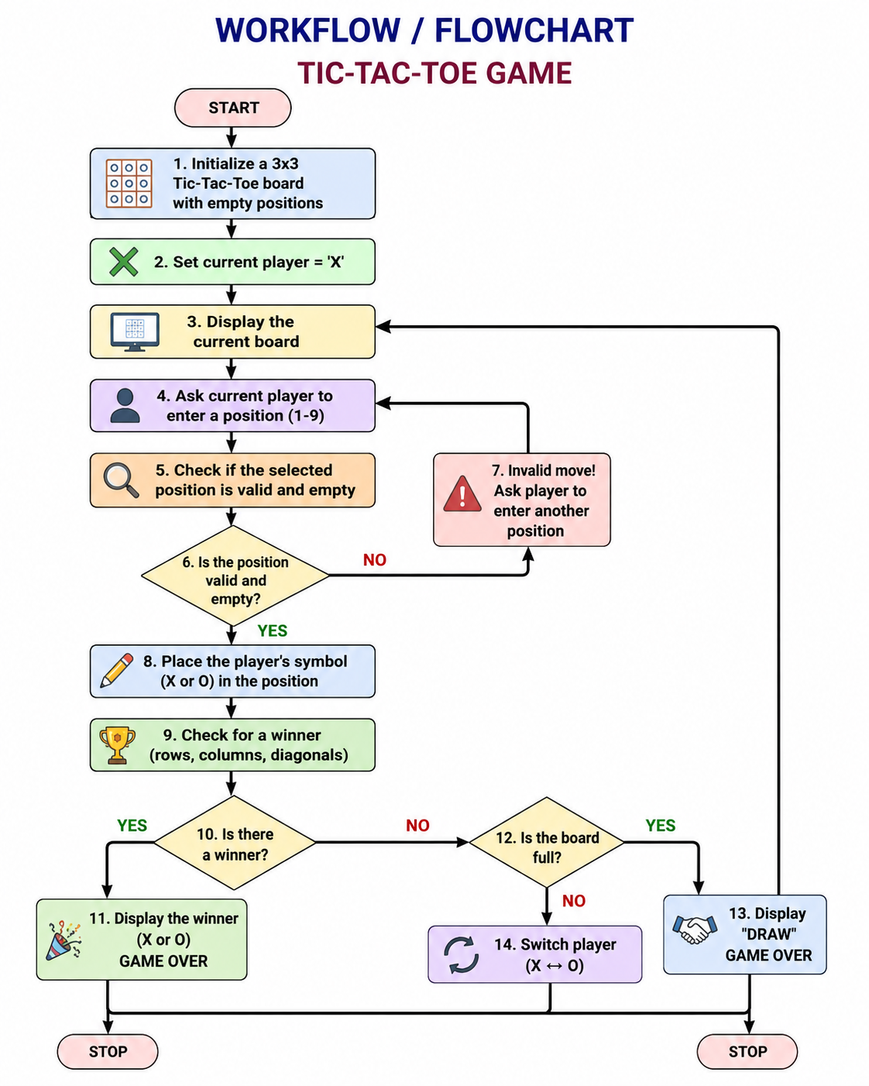

PYTHON CODE:

board = [" "] * 9
wins = [(0,1,2),(3,4,5),(6,7,8),(0,3,6),(1,4,7),(2,5,8),(0,4,8),(2,4,6)]

for turn in range(9):
print(f"{board[0]}|{board[1]}|{board[2]}\n-+-+-\n{board[3]}|{board[4]}|{board[5]}\n-+-+-\n{board[6]}|{board[7]}|{board[8]}")
p = "X" if turn % 2 == 0 else "O"
pos = int(input(f"{p} position (1-9): ")) - 1
if board[pos] != " ":
print("Invalid move"); continue
board[pos] = p
if any(all(board[i] == p for i in w) for w in wins):
print(p, "wins"); break
else:
print("Draw")

OUTPUT:
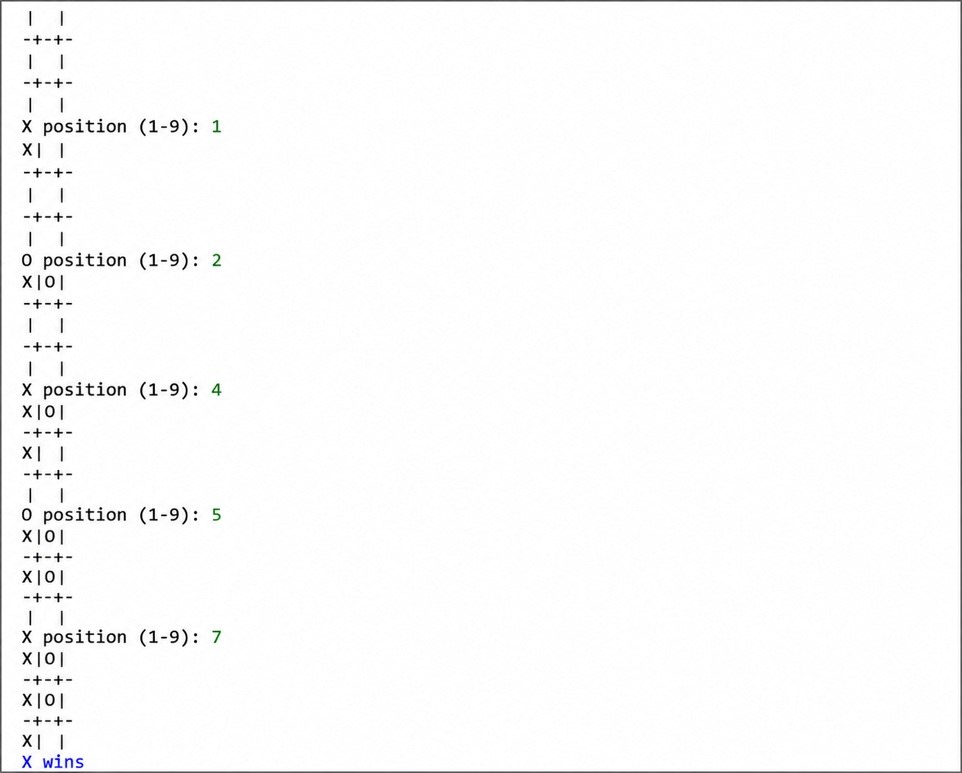

RESULT:
The Tic-Tac-Toe game executes successfully.

